In the words of a recent post on our Forum “Maths Channels are so cool” and here’s why:

Anyone using the 4000 series scope will have taken major advantage of the frequency coupling feature built into the scope when measuring a digital MAF meter output. Whilst this is an invaluable feature it is only available on one channel and so measuring frequency on multiple channels becomes an issue……or does it?

Over and above the frequency coupling feature we have a multitude of maths calculations we can make to an input signal (waveform) using the “Maths Channels” feature of PicoScope.

Clicking on TOOLS-MATHS CHANNELS from your PicoScope screen will reveal numerous “**Built-in**” maths channels that will assist you when looking at the input signals for any channel you wish. These “Built-in” maths channels will simply invert, add, subtract, divide, or multiply any combination of waveforms to any channels of interest. (The “Built-in” maths channels use channels A and B)

Let’s take a look at a CAN communication signal using channels A CAN HI and B CAN LO. With the waveform on screen click on TOOLS-MATHS CHANNELS and tick the box adjacent to A-B, then click OK. This will then display a 3rd (maths) channel with the calculation you have requested. In this case CHA A – CHA B = CAN HI – CAN LO = 0v and 2v which is this message hidden within CAN HI and CAN LO transmission.

Below we can now see the 3rd (Maths) channel but it is difficult to interpret because of the interference in the CAN HI Circuit. If you now “Right Click” on your scope screen, select “CHANNELS” and tick box A and B, you will remove these channels leaving just the maths channel behind.



The remaining maths channel clearly reveals the impact on the CAN communication message stored within the CAN signals due to the interference seen on Channel A

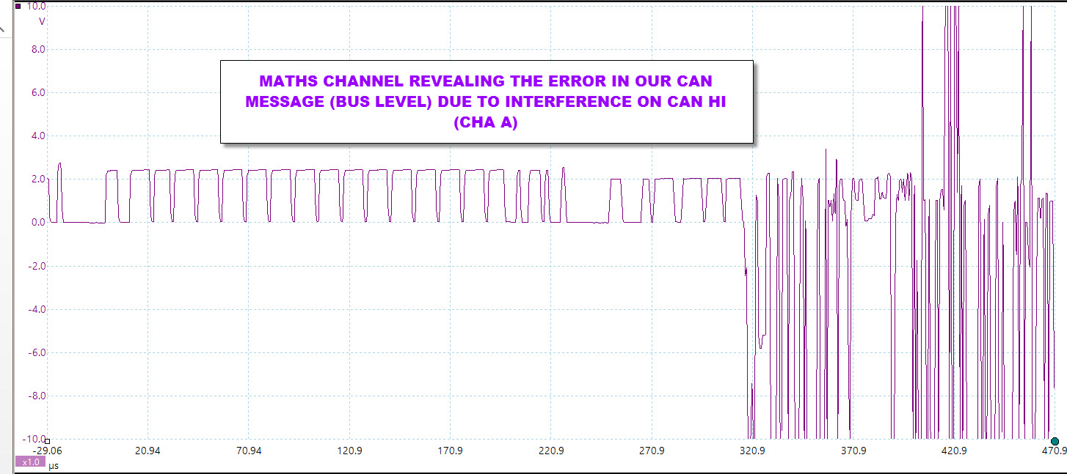

With maths Channels you are not tied down to the selection in the “Built- in” menu as you can create your own maths channel, and here is where maths channels really do become cool!

Let’s take a typical PWM signal of 0v to 5v as seen with the digital MAF sensor and assume you want to calculate the frequency of the PWM. Remember with the majority of digital MAF meters, an increase in air flow is directly proportional to an increase in the output frequency of the 5v signal.

**To calculate frequency you need to “Create” a maths channel and here is the theory:**

To calculate frequency the signal must past through zero volts (crossing point), yet our signal travels from 0v to 5v. A clever tip therefore is to split the signal in half (2.5v) and use this value as follows in the formula you are about to create. We use **“-2.5”** to effectively move the zero crossing point into the middle of the signal output. This allows the maths channel to calculate the number of crossing points in a given time to display the frequency, i.e. the number of times the signal crosses 2.5 volts

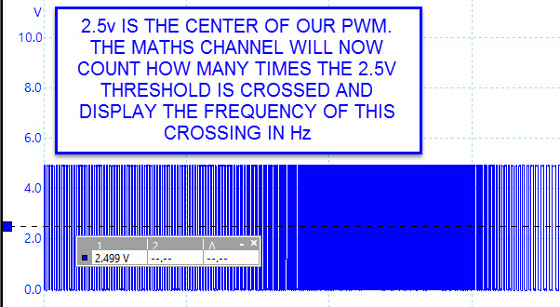

Select TOOLS-MATHS CHANNELS and then CREATE. Click on ADVANCED and then the "freq" button. When "freq( )" appears in the formula box, put your cursor in-between the two brackets "( )" and type A-2.5, the whole formula will look like **freq(A-2.5)**. Click NEXT, choose any colours, names, and ranges. It is best at this stage to set a manual override to the actual frequency range you require (in the example below I have selected 0Hz to 300Hz) and finally click FINISH. Check the box next to your created maths channel and click OK. A new 3rd (maths) channel will appear and will plot the frequency of the channel you have requested. (In our case A-2.5 is a frequency maths channel for channel A)

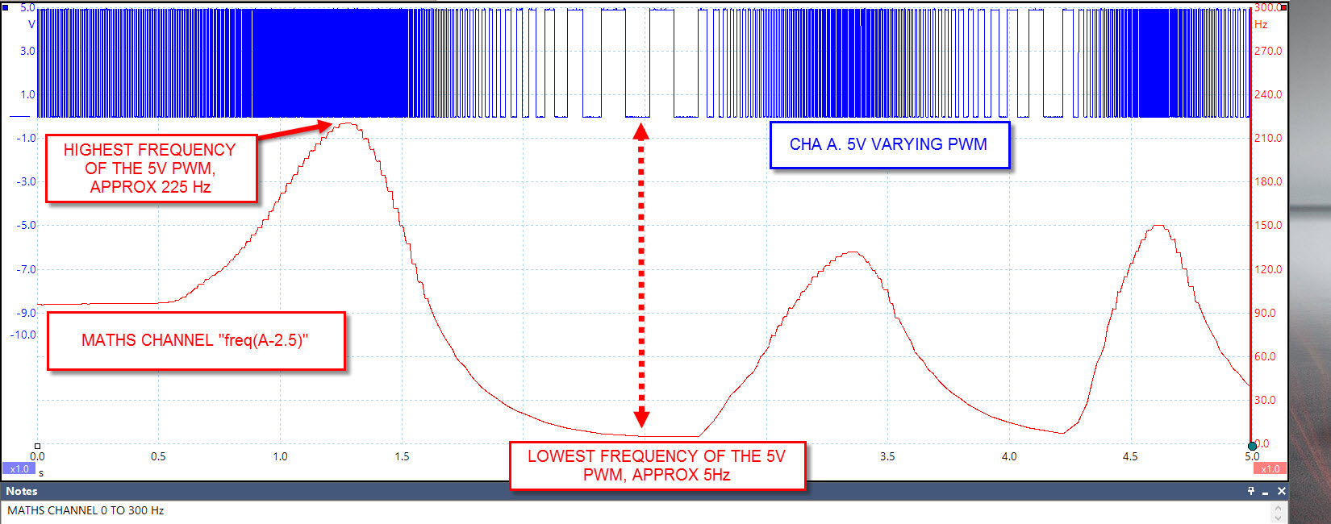

Above we can now see how the PWM changes over time by plotting the frequency with our maths channel. This feature now becomes invaluable allowing you to test dual digital MAF meters on “V” configuration engines, control valves (diesel pump), actuators (EGR) and solenoids (turbo boost control) etc. Basically anything controller via PWM can be tested using PicoScope not only for the integrity of the signal but speed of the signal over time.

Remember when creating your maths channel if you have a 0v to 12v PWM signal your formula will be **freq(A-6v)** assuming you wish to measure frequency on Channel A. When setting your scale for the maths channel 0Hz to 2000Hz will cover most control solenoids such as diesel pump inlet and turbo boost control.

Go ahead and play with the maths channel feature as it will open up a whole new world of measuring techniques revealing even more about your input signal. For any support you need regarding PicoScope please contact [support@picotech.com](mailto:support@picotech.com)